Clustering

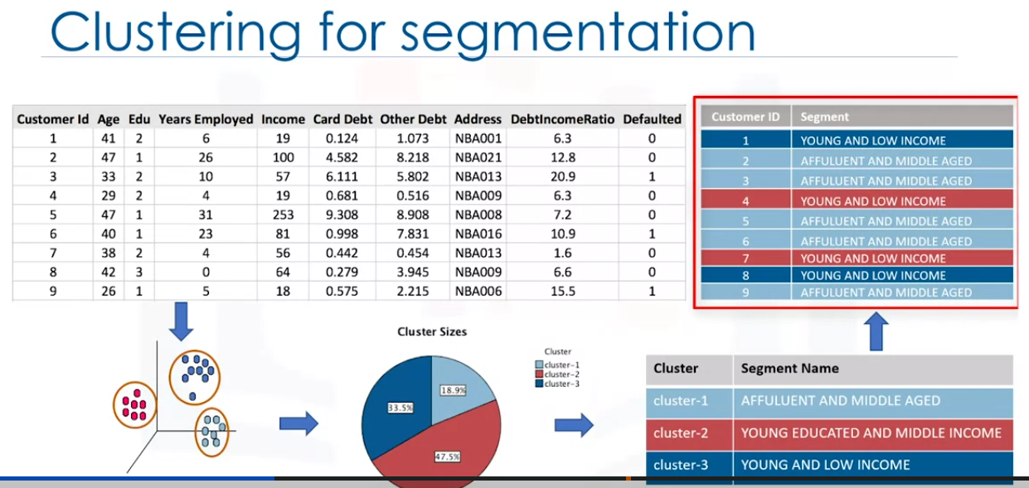

Imagine we have a customer dataset and we need to apply customer segmentation on this historical data. Customer segmentation is grouping individuals that have similar characteristics. it allows to traget customers effectively and allocate markeing resources.

For example, one group might contain customers who are high profit and low risk. This will help a business to focus on them more to retain them.

Another group might be customers that do not provide much profit and so on.

A general segmentation process is not usually feasible for large volumes of varied data. So we need an analytical approach to deriving segments and grouppd from large datasets.

Customers can be grouped based on several factors, including age, gender, interests, spending habits and so on. The important requirement is to understand and identify how customers are similar to each other.

Lets learn how to divide a set of customers into categories, based on charactristics they share. One of the most adopted approaches for custmer segmentation is clusturing.

Clusterring is a unsupervised, based on the similarity of customers to each other.

It partitions customers into mutually exclusive groups. In this example we have 3 clusters.

Now we can create a profile for each cluster considering the common characteristics of each cluster.

For Example:

cluster 1 contains affluent and middle aged customers.

cluster 2 contains young and educated middle income customers

cluster 3 young and low income customers.

We can use these profiles and assign them to each individual customer in the dataset.

Once we get the new profiles for each customer, the new data will help predict the differences and individual customer preferences and their buying behaviours across various products.

This will help to create highly personolized advertising for each segment.

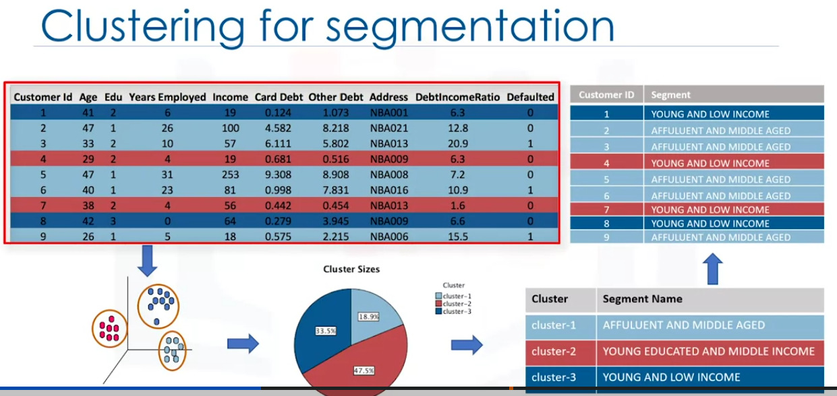

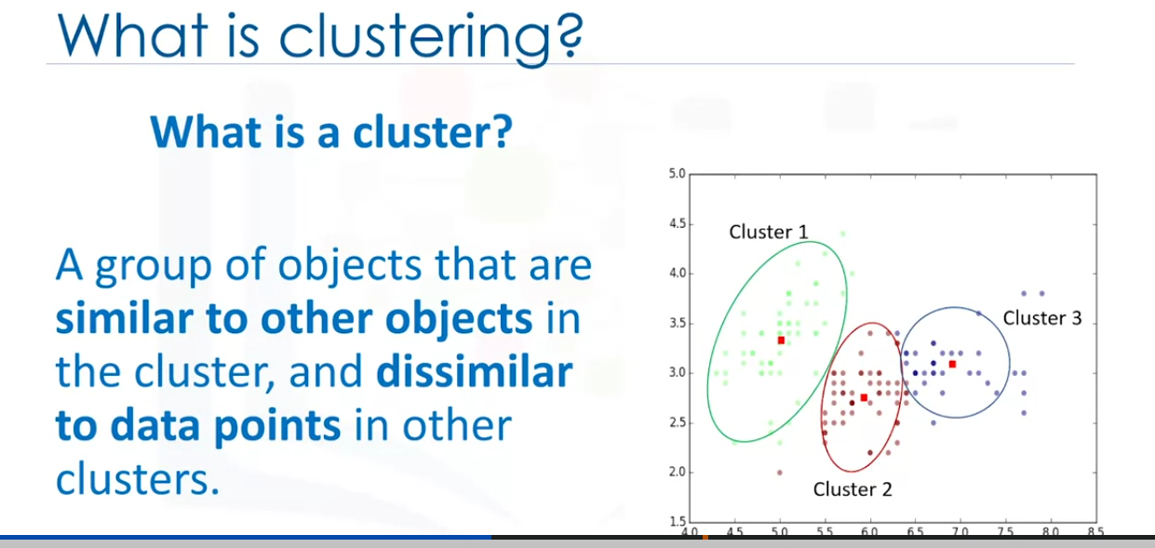

lets see what is Clustering:

Custering is a an Unsupervised learning model that groups data into different clusters.

A cluster is group of objects that have similarities between them.

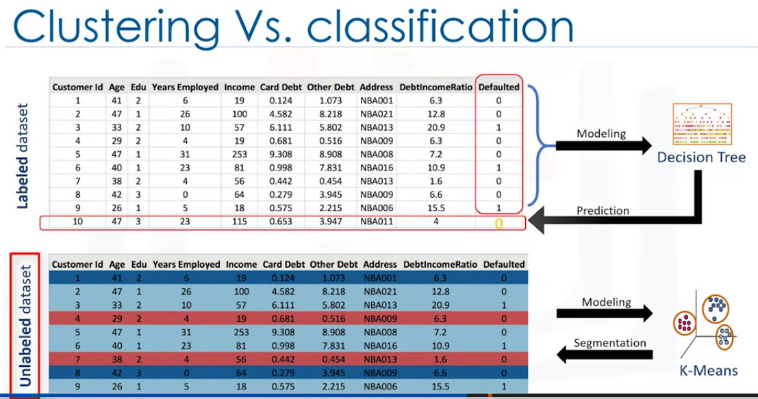

Now what is difference between clustering and classification?

Classification is a Supervised learning model that predicts classed labels. classes are already existing.

When it comes to clustering its an unsipervised learning, that preficts clusters that the objects belongs . The labels are not already available.

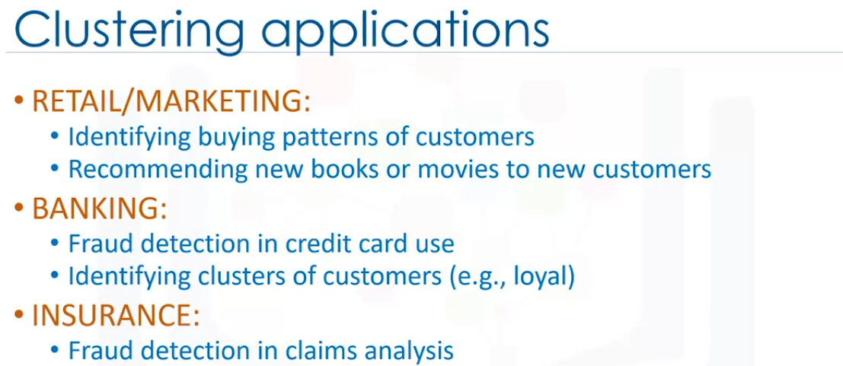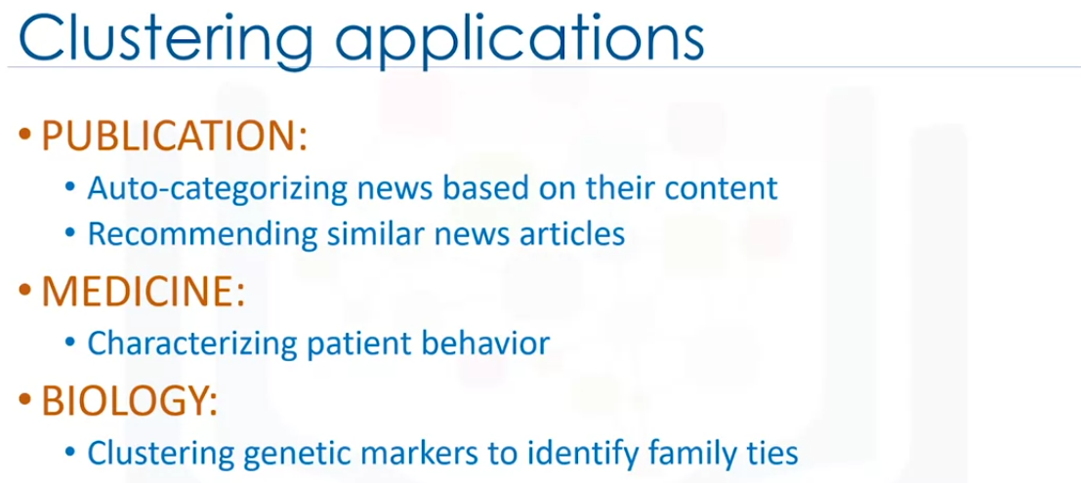

There are more applications for clustering but they follow specific purposes.

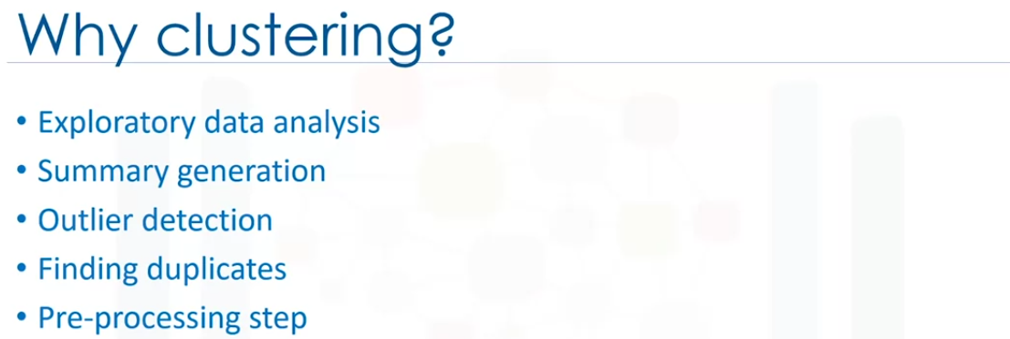

Lets see the different clustering algorithms.

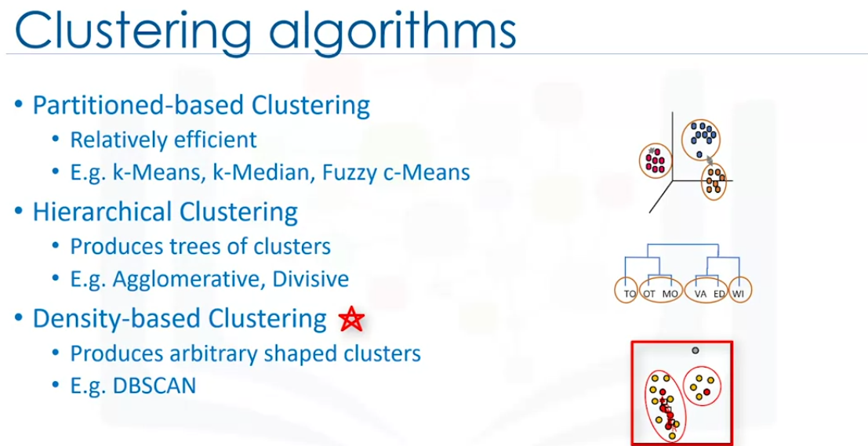

Patition- based clustering creates sphere-like clusters. Efficient and are used for medium and large sized databases.

heirarchical clustering creates trees. very intuitive. for small size datasets.

Density based custering algorithms - creates arbitrary shaped clusters. Good when using spacial cluster or if there is noise in the dataset.

K-Means Clusterin

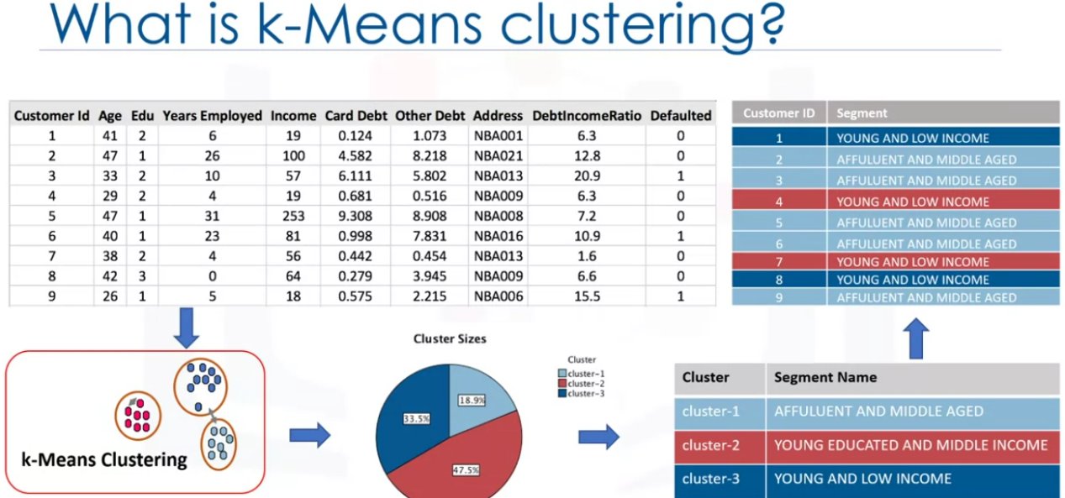

Customer segmentation example.

We can use K-means clustering.

Unsupervised. Based on Similarities

There are different types of clustering like partitioning Custering, density based clustering and Hierarchical Clustering.

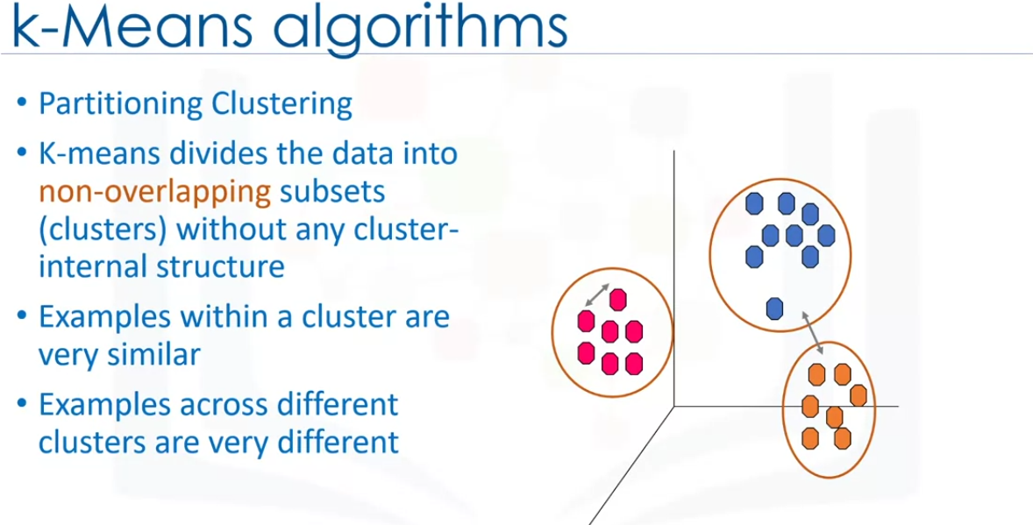

Without internal structure means without any label. In other words its a unsupervised learning algorithm.

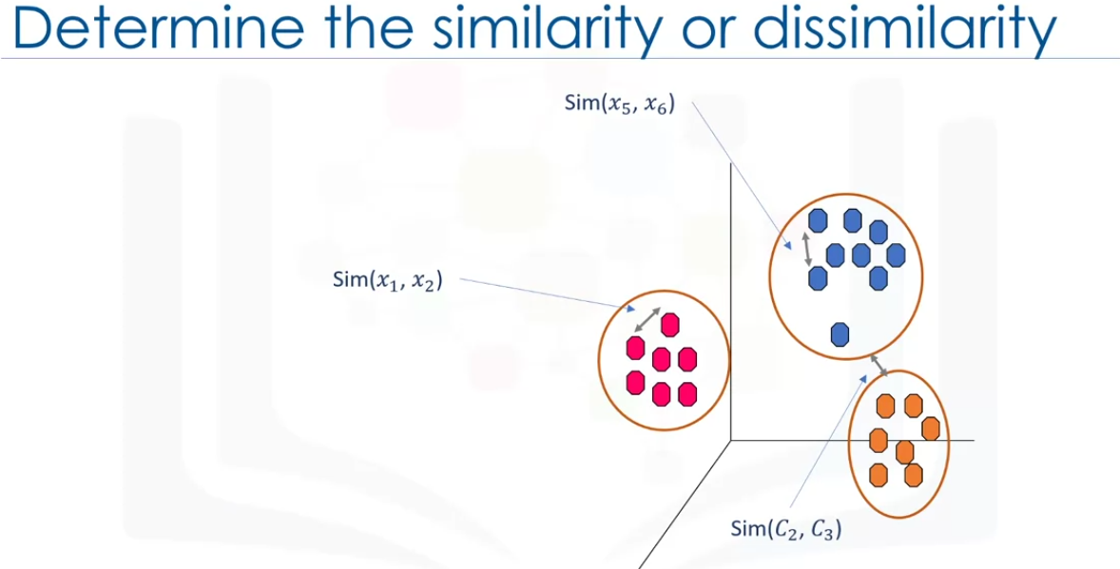

To create a clusters, we need to find similar data points.

How can we find the similarity of samples in a clustering and how do we measure how similar two customers are with regards to thier demographics?

We can use dissimilarity metric to create different clusters. This means the distance between two data points can be used to shape the clusters.

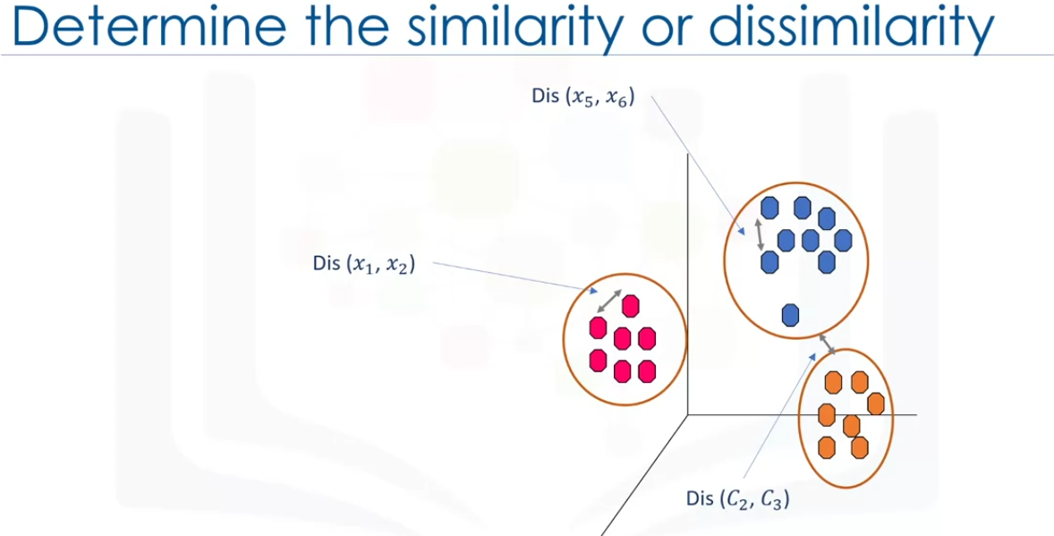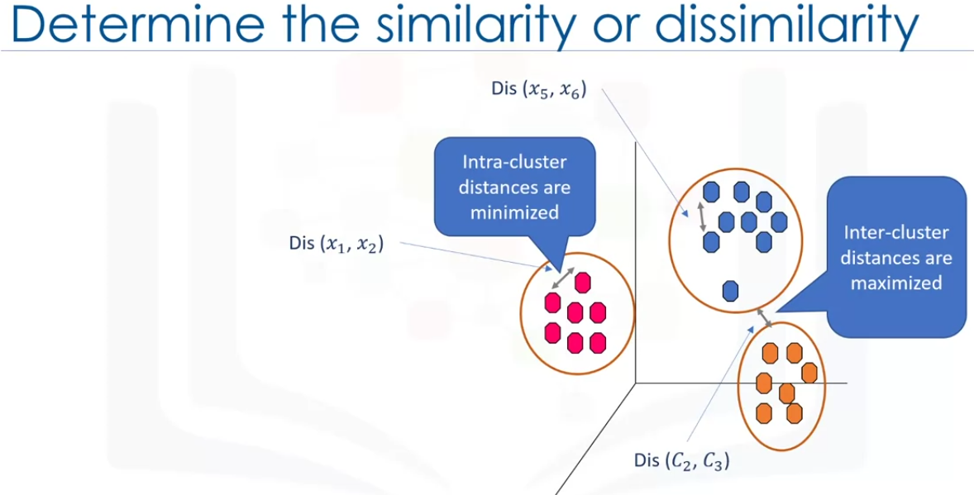

The distance between the two clusters is called inter-cluster distances which needs to be maximised. And the Intra-Cluster distances which is the distance between two points in the same cluster needsto be minimized.

Now, how can we calculate the dissimilarity or the distance between 2 custormers?

There are 3 situations:

1D, 2D , ND

The formulas are shown in the following images. Its simply euclidean distances.

But we need to normalize the data to get a proper dissimilarity measures.

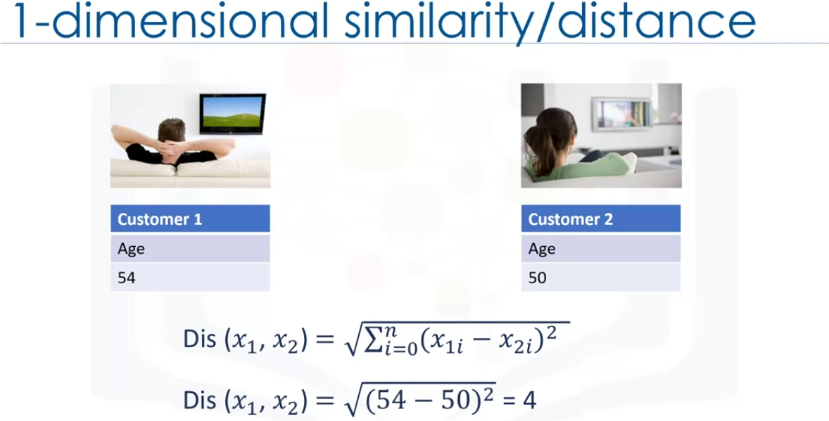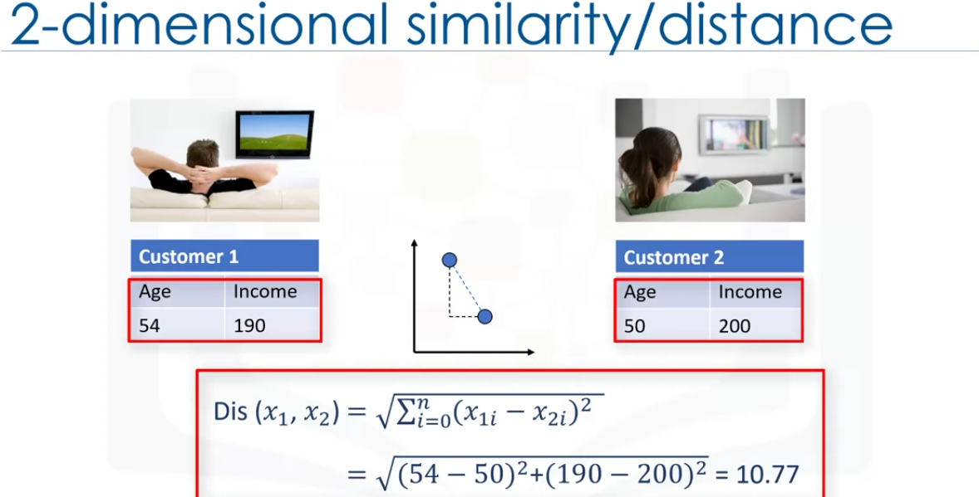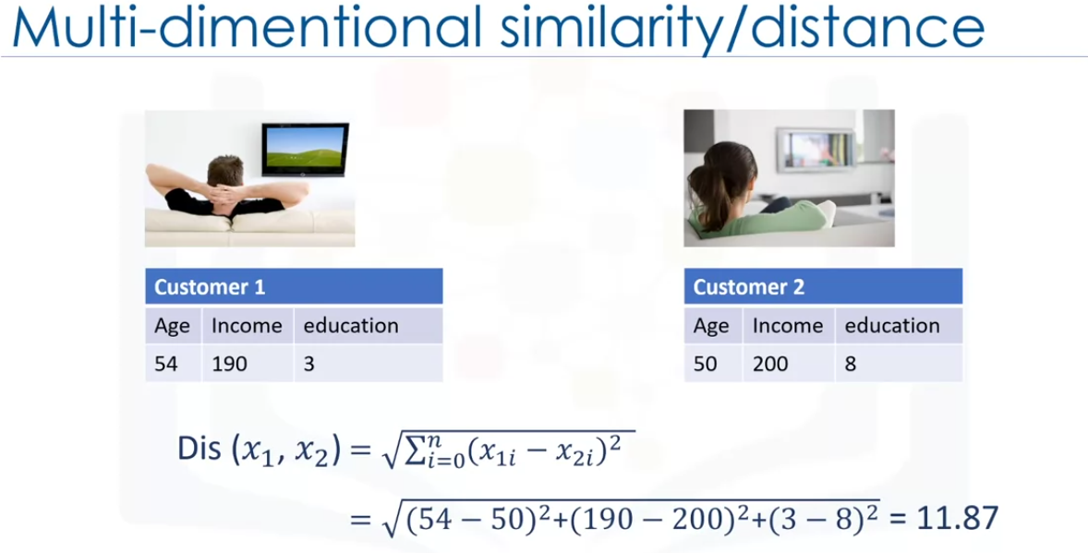

There are other dissimlarity measures . It all depends on datatype and the domain of the problem which one to choose.

Example: euclidean distance, cosine similarity, average distance and so on.

These control how the clusters are formed.

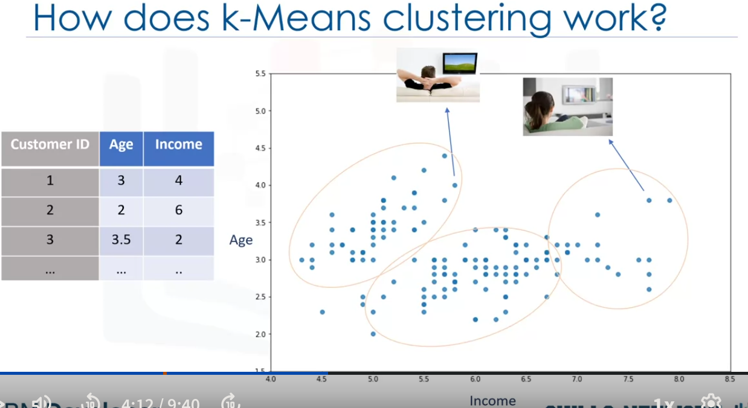

Lets look at the innerworkings of k-means clustering

Lets take 2 dimension for simplicity.

we can use scatter plot.

y- age

x- income

we can now divide the data into clusters.

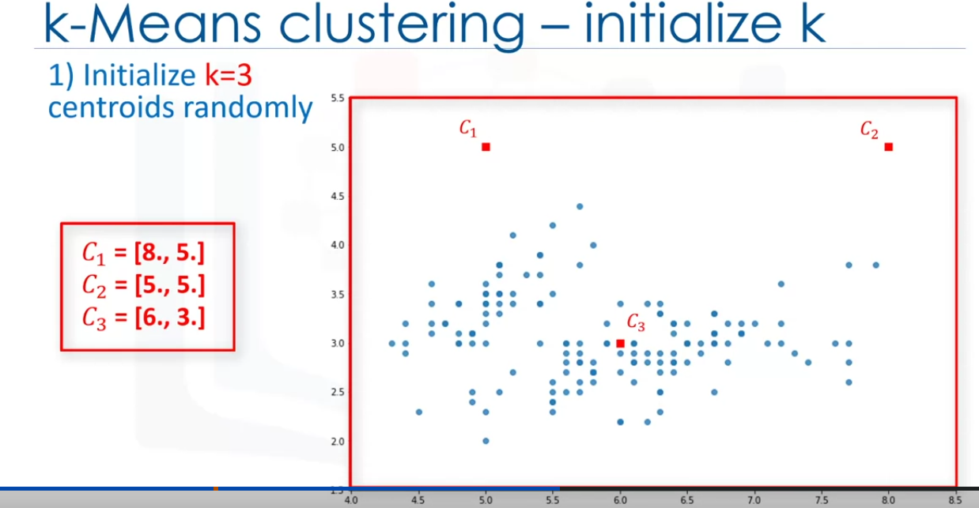

Step 1 is to decide how many clusters we want .

The clustering algorithm picks a random point for representing center of clusters. In this case, C1, C2 and C3.

But deciding the number of cluster is a hard decision. We will see how to decide it later.

Lets consider K= 3 for now which gives us C1, C2, C3. These are called centroids of a cluster and should be of same deature size as the customer feature set.

There are 2 ways to get the centroids.

1. choose 3 random points on the scatter plot and have them as centroids.
2. Create 3 random points that we can consider as centroids.

here we are option the second approach.

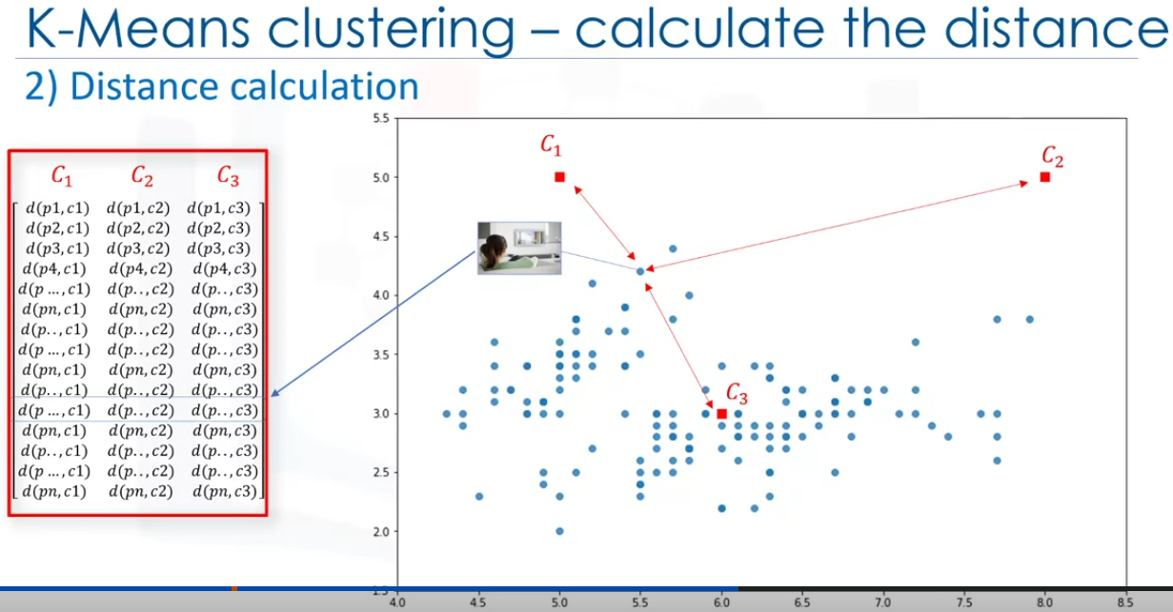

Now as have the centroids we need to assign each data point to a ckuster and this is done by calculating distance of each datapoint with the centroids. We will get a 2d data structure that contains all the distances like shown in the image above. It is called the ditance matrix.

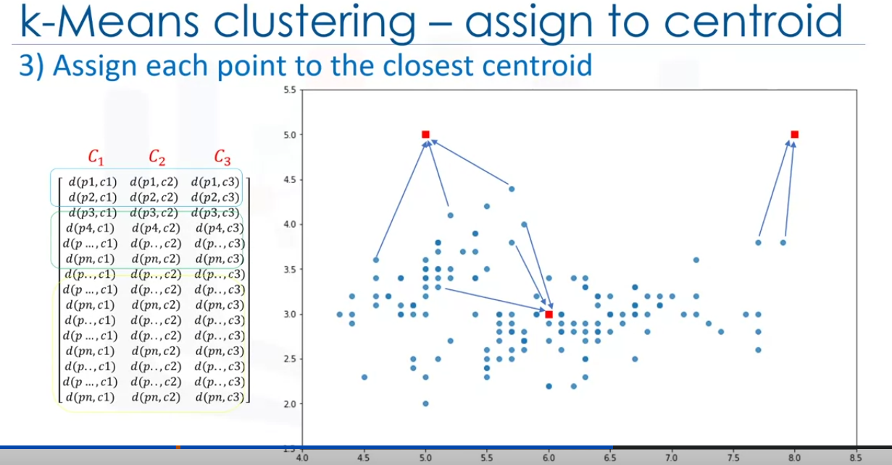

Now we need to find the closest centroid for each datapoint and assign it to that cluster. We can use the ditance matrix to do that.

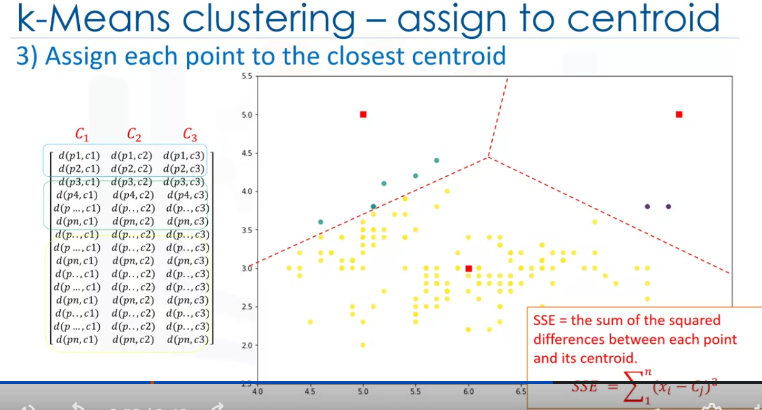

We can see that these dont form a custer. This model will give us a high error. To calculate the error we find the total distance of each point from the centroid. The formula is shown in the image. It is called as Sum of Sequared Errors (SSE). We need to reduce the error to make an accurate model. Which means the total distance of each point from the centroid is minimized. In other words we need to radius of the custer should not be very large.

To do this we move the centroid to a different point which will minimize the error.

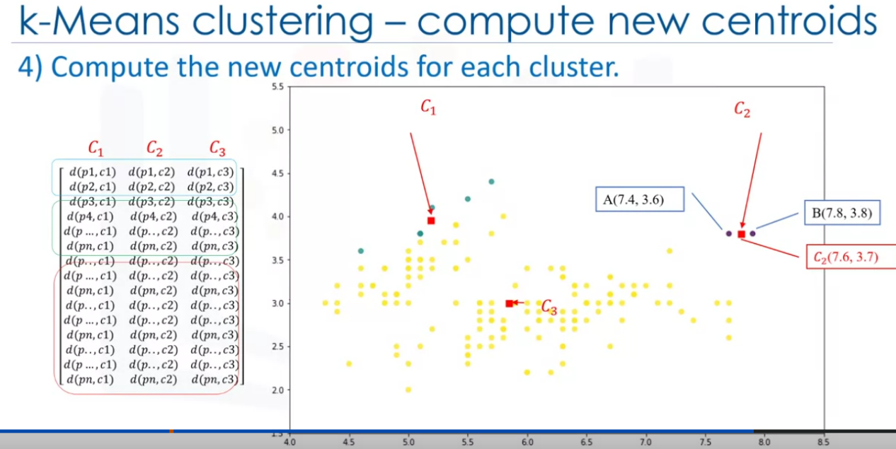

This can be done by calculating the mean of the datapoints in the current cluster and we move the centroids.

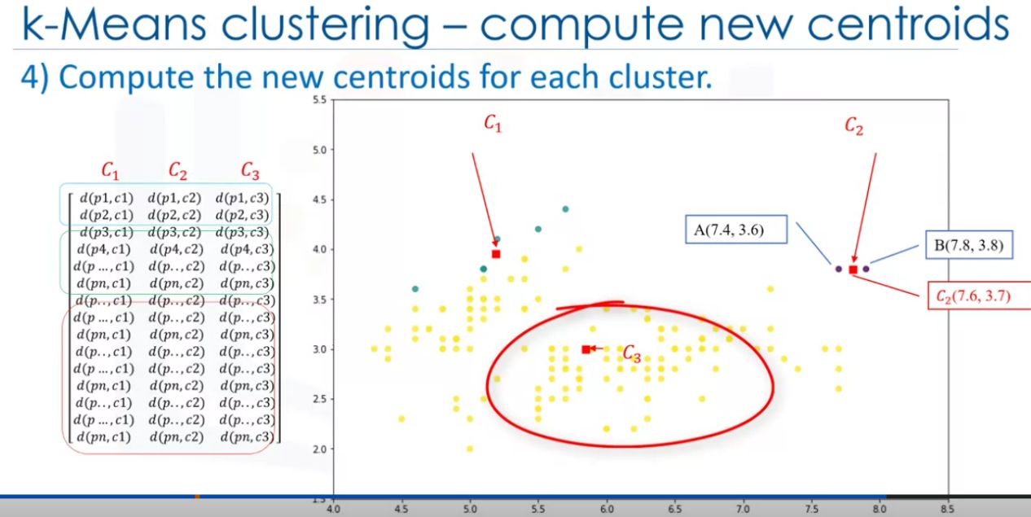

We can see from the image, C2 is the mean value for the A and B.

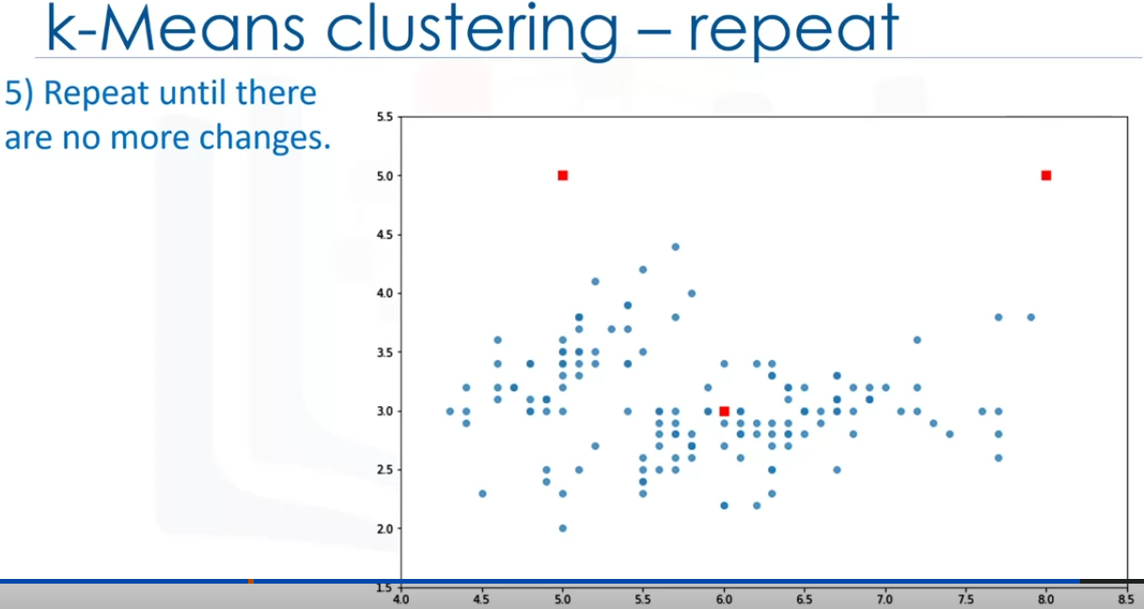

Then we once again assign each data point to new centroids.

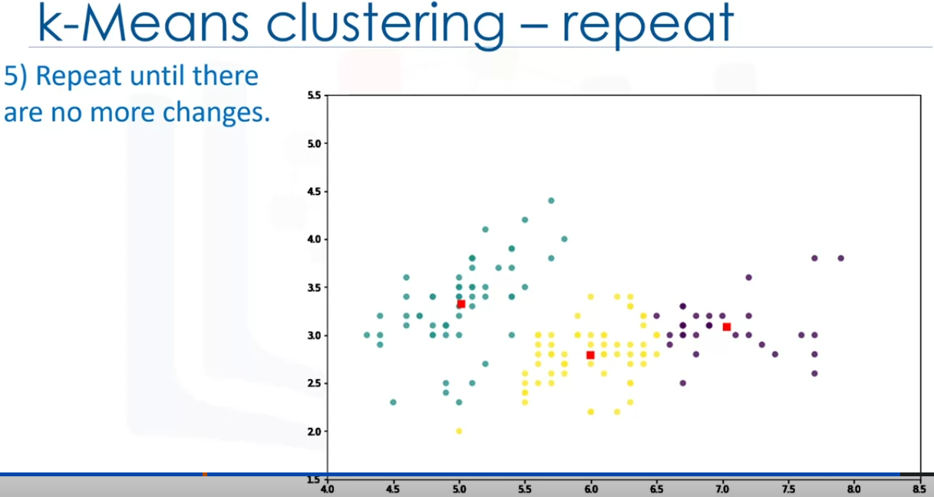

Then we calculate the means again and repeat the steps till we low enough error.

We stop this process when the centroid does not move anymore.

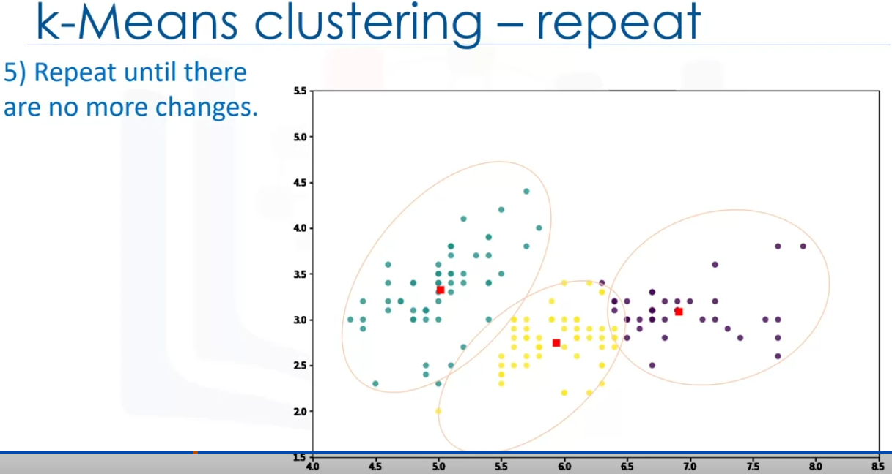

However as it is a heuristic algorithm, there is no guarantee that it will converge to the global optimum and the result may depend on the initial clusters.

This means this algorithm gives a local optimum not necessarily best possible outcome.

To solve this problem, It is common to run the whole process multipple times with different starting condtions(randomized stating centroid may give better outcomes).

Kmeans algorithm is very fast so it will not be a problem to run it multiple times.

More about k-means Clustering

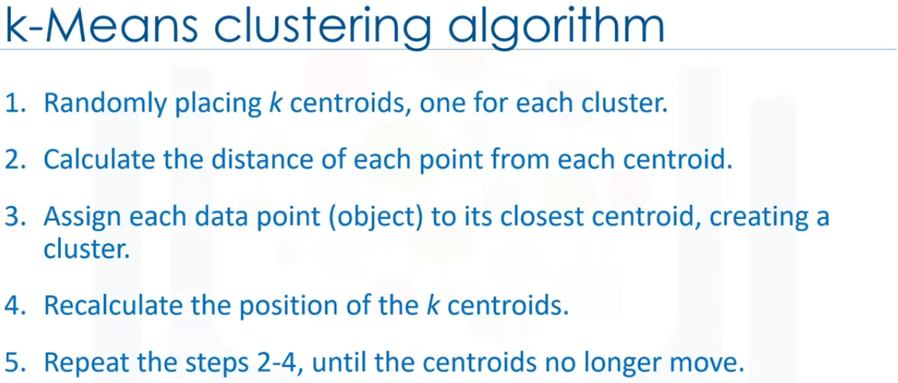

How dowe find the accuracy of the clusters?One way to calculate the accuracy is to compare the clusters with the ground truth if it is available. This is not likely to be possible as the model is unsupervised(labels do not exist).

But still there is a way to tell how bad each cluster is. by calculating the average distance between data points within a cluster. Also average distance of each datapoint from cluster’s centroid can also be used as a metric.

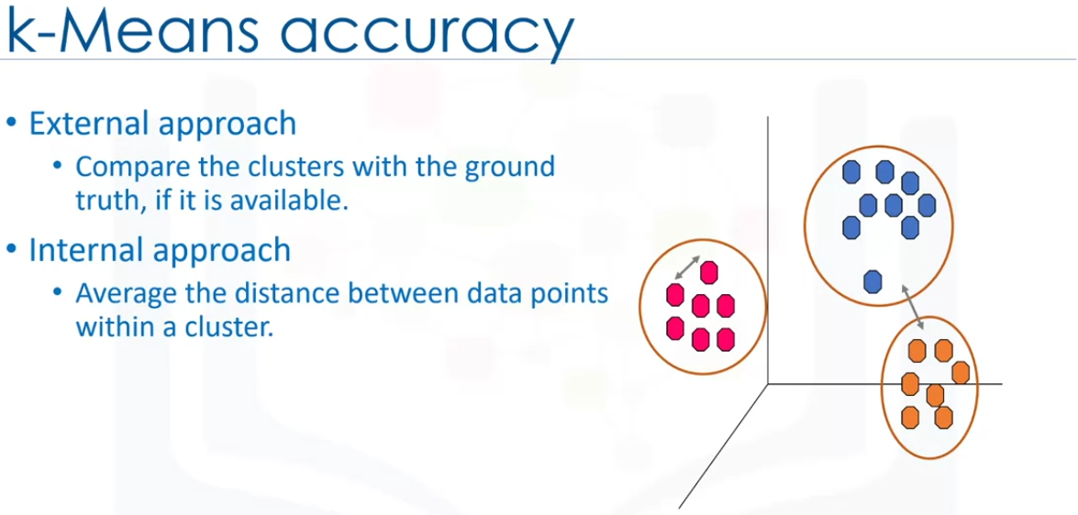

Choosing the k valus is a hard task and ambiguous for most part. It is very dependent on the shape and scale of the points in the dataset.

There are some approaches to address this problem, but commonly used appoach is running clustering using different K values and looking at a metric of accuracy for clustering. This metric can be the mean distance between the data points and their cluster’s centroid which indicate how dense our clusters are or to what extent we minimize the error of clustering. Using this we can find the value of K.

If we keep increasing the k value, the distance keeps reducing. So when do we stop?

We can also plot it on the graph and we can pick the k value by looking at the elbow point. This is the point where the error metric sharply shifts. 